**Gary Chen**

Problem Definition Worksheet (Part of Your Process Improvement Project)

Background about the Process Improvement Project

**Project Selection Criteria**

Select an issue or opportunity that can be written as a problem statement.

* Must be within your sphere of influence
* Is not an attempt to solve world hunger
* Uses data that is accessible to you or can be collected in a reasonable amount of effort/time
* You have the ability to measure the current and future state; you have access to baseline data or can collect it
* Preferably uses more continuous data (rather than all discrete data)
* Fixing this problem will provide value; you should develop a business case to support working this issue (consider your time and others when calculating ROI)

**Examples**

* Improve product quality
* Reduce expenses
* Improve the output of your organization
* Decrease wait time

Problem Definition Worksheet

Complete each section:

**A. Problem statement.** Define your problem. What pains are you (or your customers, family, clients, etc.) experiencing? What is broken, wrong, or not working? How do you know that you have a problem? What is telling you this? What is your evidence?

My problem is finding the best way to get back all the weightlifting strength that I lost since the COVID gym shutdowns. The gyms in New York have just opened back up about a month ago and it is very evident that I am not as strong or as consistent of a gym goer as I used to be. My numbers in the big three lifts (bench, squat, deadlift) are significantly down. When the gyms opened back up, I went back without a training program and without a laid-out workout schedule. With the lack of exercise and activity over the last 6 months, I feel like my muscles and joints are much more tense and to a certain extent, it has taken a mental toll. Along with the strength lost, it has been harder to perform bench, squat, deadlift, and military press exercises.

**B. Business impact.** Why should you fix this problem? What is the estimated benefit for solving this problem? What is this problem worth in dollars? How will you measure success? What is your key output (*y*)?

Powerlifting has given me an outlet for stress relief and more confidence to tackle other challenges of my life. I take pride in my lifting numbers and I want to regain my gains as soon as possible. I have been going to the gym since I was a 17, and it is something that I would love to continue doing at a high level. The benefits of this is priceless but if I were to put a dollar amount on it, I would calculate it by milestones compared to my old lifting numbers. I will be following the ”Starting Strength program”. The key output(y) will be the progression of my bench, squat, deadlift, and military press lifting numbers for working sets of 5 repetitions over the next 7-8 weeks. I will also test my 1 rep max numbers after this program as a bonus dollar amount to the money question.

**Dollar Calculator:**

|  |  |  |  |  |  |
| --- | --- | --- | --- | --- | --- |
| **Dollar Calculations** | | | | | |
|  | **80%** | **90%** | **100%** | **100%+** | **1 rep bonus** |
| **Bench** | $1,000 | $1,500 | $2,500 | $2400 + $1.30(lbs) | $1.15(lbs) |
| **Squat** | $1,000 | $1,500 | $2,500 | $2400 + $1.25(lbs) | $1.10(lbs) |
| **Press** | $1,000 | $1,500 | $2,500 | $2400 + $1.35(lbs) | $1.20(lbs) |
| **Deadlift** | $1,000 | $1,500 | $2,500 | $2400 + $1.20(lbs) | $1.05(lbs) |

**C. Goals.** What are your improvement objectives, goals, or targets? How much "better" do you want to be? Quantify this goal.

My goal is to get back 90% of what my old three sets of 5 rep numbers were for squatting, pressing, and benching. For deadlifting, my goal will be getting back 90% of what my old one set of 5 rep numbers were since this is a more strenuous exercise and there is only one working set in the “Starting Strength program”. I am targeting to go to the gym 3 times per a week for the next 7-8weeks.

|  |  |  |  |  |
| --- | --- | --- | --- | --- |
| **Previous numbers(lbs)** | | | | |
| **Exercise** | **Bench** | **Squat** | **Press** | **Deadlift** |
| **3 x 5** | 255 | 315 | 135 | 355 |
| **1 x 5** | 275 | 345 | 155 | 395 |
| **1 x 1** | 290 | 365 | 175 | 425 |
|  |  |  |  |  |
| **Current Baseline numbers(lbs)** | | | | |
| **Exercise** | **Bench** | **Squat** | **Press** | **Deadlift** |
| **3 x 5** | 175 | 225 | 85 |  |
| **1 x 5** |  |  |  | 265 |
| **1 x 1** |  |  |  |  |
|  |  |  |  |  |
| **Goal numbers(lbs)** | | | | |
| **Exercise** | **Bench** | **Squat** | **Press** | **Deadlift** |
| **3 x 5** | 230 | 285 | 125 |  |
| **1 x 5** |  |  |  | 355 |
| **1 x 1** |  |  |  |  |

**D. Project scope.** What are your boundaries? What is the first step and last step of the process you need to fix? What is not within your scope?

The first step of this process is finding a workout program which will be “Starting Strength”. I will start and collect data for the program on October 12th. The workout program has 2 different workouts which each will consist 3 out of the 4 exercises that I mentioned. Here are some of the logistics of the program.

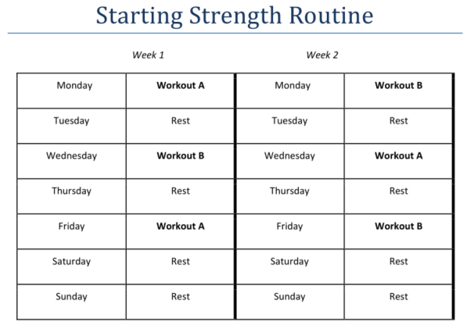

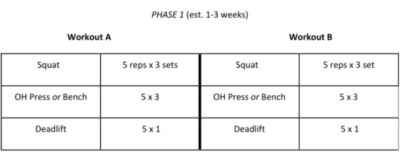

In addition to tracking my workouts, I will be tracking the time that I start my workouts(morning, noon, evening) , duration of stretching, amount of sleep I get each day, if I hit the daily 2,800 calorie goal(yes/no), weight at the beginning of each week, which gym I go to(UFC/NYSC), alcohol intake, and if I saw my physical therapist during the week.

I might have to adjust my calorie intake because 2,800 calories is what I need to maintain my body weight. This is a very strenuous program, and I might need to increase my calories to keep up with the physical demands. I have access to 2 gyms (UFC/NYSC). UFC is closer to my home but is a smaller gym. NYSC is a further commute but has a better selection of Olympic lifting bars. I want to see if going to either gym will affect my performance.

For not within my scope, I will not be able to control if there will be additional COVID gym shutdowns. Getting sick or having an injury will also put a damper on this project.

**E. Team.** Who is the process owner/champion? Who do you need to work with or involve to analyze and/or impact this process?

I am the process owner/champion. This is a project improvement on myself and I will be responsible for all results produced from this methodology.

**F. Project plan (very high-level).** Estimate time (or date) per DMAIC step. Develop a rough timeline.

I will be tracking my workout progress for the next 7-8 weeks. I will start and collect data for the program on October 12th and hopefully finish by December 6th. Phase 1 of the Starting Strength program will last for about 3 weeks. I will see how my body is feeling and figure out if I should adjust the program. Every 2 weeks, I will be looking at my sleeping and calorie intake habits to get gather further insight. By the end of October, I should be able to conclude which gym is best for me. My current aim is to see my physical therapist at least once a month but will be opened to additional appointments if needed. At the end of the 7-8 weeks is when we can do a deeper analysis on my findings and see if I reach my goals.

**G. Process map.** What are the steps in the process you are trying to fix? Document the flow of process steps (of the process you are working to improve). This should be a high-level flow chart.

Track weight weekly

Track Stretch duration before each workout

See Physical Therapist when needed

**HIT OLD LIFTING NUMBERS!!**

Increase or decrease working set weight by 5-20lbs weekly

Track number of days in the gym per a week

Track calorie goals

Track Sleep

Track Alcohol Intake

Find which work out time works best

Track start of workout time

Body Building/volume program

NYSC Gym

UFC Gym

Choose gym

Strength program

Choose lifting program

Gain Back Gym lifting Strength